CASE STUDY:4
Title: ATM Card PIN Verification Using JavaScript Functions
Software/Tools Required: VS Code, Web Browser, HTML, CSS, and JavaScript
Theory: An ATM system can verify whether a customer’s PIN is a palindrome using JavaScript functions. A function is a block of code that performs a specific task and can be reused. JavaScript supports different ways to create functions, such as function declaration, function expression, and arrow function.In this experiment, one function is used to reverse the entered PIN, and another function is used to check whether the original PIN and reversed PIN are the same. If both are the same, the PIN is a palindrome.JavaScript also follows scope rules. Variables declared outside functions have global scope, variables declared inside functions have function scope, and variables declared using let or const inside { } have block scope.The program displays a special security message if the PIN is a palindrome; otherwise, it displays a normal message.
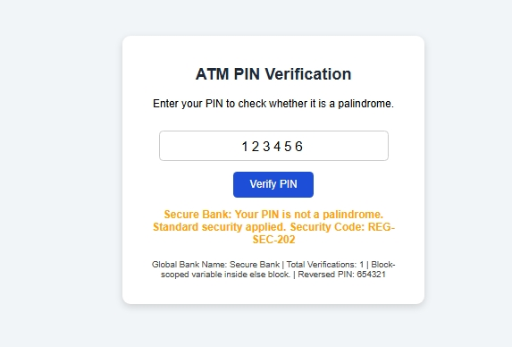

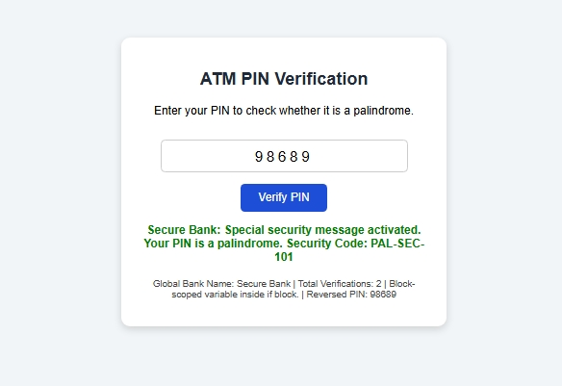

Result: The ATM PIN verification program was successfully developed using JavaScript functions. When a palindrome PIN such as 12321 or 1001 was entered, the system displayed the special security message. When a non-palindrome PIN such as 12345 was entered, the system displayed the normal security message.successfully map the average to the appropriate letter grade (A to F), dynamically update the result card UI (including the animated score bar and highlighted grade scale), and seamlessly add the student's record to the grade history table.
Conclusion: From this experiment, we learned how to create and use JavaScript functions using function declaration, function expression, and arrow function. We also learned how to reverse a PIN, check whether it is a palindrome, display alert messages, and understand global, function, and block scope.

